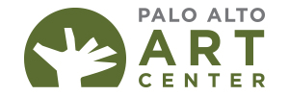 | 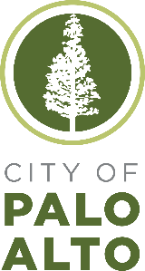 | MEDIA CONTACT  Karen Kienzle  Palo Alto Art Center Director  650.617.3535  karen.kienzle@cityofpaloalto.org
September 9, 2024 For Immediate Release
“GROW” Exhibition Celebrates Gardens, Parks, and Plants in Art
Palo Alto Art Center Exhibition Features Twenty-Two Artists
Explore Topics From Sustainability to Labor
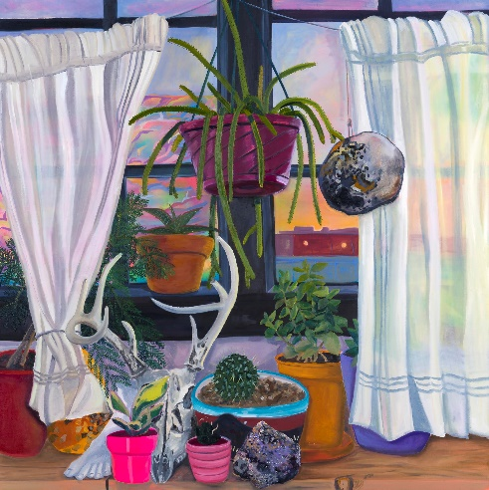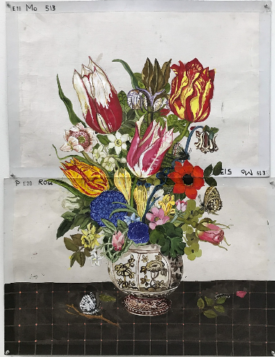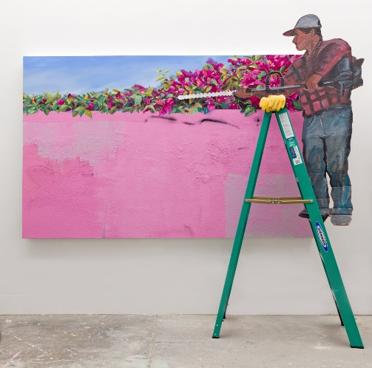
Images from left to right: Anna Valdez, Windowsill, 2017, Oil, acrylic, and spray paint on canvas, 55 x 55 in., Courtesy of the artist and Hashimoto Gallery, San Francisco; Katherine Sherwood, Three Moths (after Rachel Ruysch), 2019, Acrylic and digital print on found cotton duck, 35 x 45 in., Courtesy of the artist and Anglim Trimble Gallery, San Francisco; Jay Lynn Gomez and Patrick Martinez, Against the Wall , 2019, Acrylic paint, latex house paint, spray paint, cardboard, ladder, work gloves and stucco on panel, Installation dimensions: approx. 90 x 80 x 24 in., Courtesy of Charlie James Gallery, Los Angeles.

PALO ALTO, CALIF.--The Palo Alto Art Center presents the “GROW” exhibit Sept. 21-Dec. 15, 2024. Featuring the work of 21 artists throughout the country working in a wide range of media, the exhibition explores the gardens from our memories, imagination, and history; the gardens and green spaces we share; and the gardens that grow us toward a better future, highlighting sustainability and responses to climate change. “GROW” is guest curated by Marianne K. McGrath.
Guest curator McGrath shares her inspiration for the exhibition: “The tangible practice of growing food, flowers, and plants grounds us, draws our attention to our senses and brings us fully into the moment as our hands work the soil. This experience ties us to the changing seasons, the passage of time, and the realities of our climate. As we engage with the rhythms of nature and recognize the fragility of our planet, gardening also prompts us to contemplate broader human experiences and the ways that our gardens reflect our social structures. Issues of accessibility and equity are significant concerns when it comes to the land and growing practices. However, one does not need to own a plot of land to be a gardener. Even a collection of plants on a windowsill can form a garden, offering us joy, connection and a bit of paradise, perhaps even our own Eden as we create a sense of place and home.”
“We hope that GROW helps to highlight the verdant spaces around the Art Center, including the public and private parks and gardens throughout our community—all through engaging contemporary art,” says Karen Kienzle, Palo Alto Art Center Director. Programming presented in conjunction with the exhibition will highlight community partners, including the Rinconada Community Garden, Canopy, and Gamble Gardens.
Artists in the exhibition include: Alisa Banks; Renée Bott; Natalya Burd; Genevieve Cohn; Glenn Hardy, Jr.; Jay Lynn Gomez; José Joaquin Figueroa; Nicholas Bono Kennedy; Pantea Karimi; Jane Kim ; Stefan Kürten; Kija Lucas; Patrick Martinez; Melissa Mohammadi; Takeshi Moro; Dominique Pfahl; Callan Porter Romero; Katherine Sherwood; Terremoto; Tiffanie Turner; Anna Valdez; Connie Zheng.
Special projects presented in the exhibition include a site-specific installation by San Jose-based artist Pantea Karimi developed for “GROW” inspired in part by a botanical garden in her birthplace of Shiraz, Iran. Oakland-based artist Kija Lucas will create a site-specific project, The Enchanted Garden drawn from her experiences growing up in Palo Alto and the botanicals that surround us. Lucas uses photography to explore ideas of home, heritage and inheritance, immersing viewers with wallpaper prints in the exhibition’s Glass Gallery as well as through prints installed on the Art Center’s façade and Sculpture Garden windows.
Kicking off the exhibit with an opening celebration in September, a range of free programming continues through the fall and winter, offering the community a chance to connect, explore and grow. From an author talk, panel discussion, garden walk and family day, there is something for everyone. This project is supported in part by the National Endowment for the Arts.
ASSOCIATED PROGRAMS:
For the full list of extensive programming organized around the exhibition is listed at www.cityofpaloalto.org/grow.
Featured programming includes:
Friday Night at the Art Center opening celebration—Friday, September 20, 6-8 p.m., FREE

Palo Alto Art Center Foundation members’ preview at 5 p.m., free and open to the public at 6 p.m. Celebrate GROW with hands-on art activities and specialty garden-inspired cocktails.
For more information, please visit: https://www.cityofpaloalto.org/Events-Directory/Community-Services/GROW-Friday-Night-at-the-Art-Center

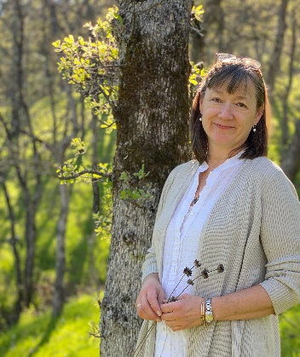
What We Sow in Cultivating Our Places: How a Garden Culture of Care Grows Places and Their People: A Talk with Jennifer Jewell—Saturday, October 19, 2 p.m., Art Center Auditorium, FREE
Jennifer Jewell is the host of the national award-winning weekly public radio program and podcast Cultivating Place: Conversations on Natural History and the Human Impulse to Garden. In her presentation, Jennifer Jewell will explore the philosophy of Cultivating Place, her national, award winning-public radio program and international podcast, based on the belief that gardens/gardeners are powerful agents and spaces for potentially positive change in our world, helping to address challenges as wide ranging as climate change, habitat loss, cultural polarization, and individual and communal health and being. For more information and to register, please visit: https://www.cityofpaloalto.org/Events-Directory/Community-Services/What-We-Sow-in-Cultivating-Our-Places-How-a-Garden-Culture-of-Care-Grows-Places-and-Their-People-A-Talk-with-Jennifer-Jewell
About the Palo Alto Art Center:
The Palo Alto Art Center is your place to see and make art, activate your creativity, and expand your community. Created by the community, for the community in 1971, the Palo Alto Art Center provides an accessible and welcoming place to engage with art. We engage approximately 150,000 people every year through a diverse range of programs.
The Palo Alto Art Center, Division of Arts and Sciences, Community Services Department, City of Palo Alto is funded in part by grants from the Palo Alto Art Center Foundation. The Palo Alto Art Center Foundation gratefully acknowledges support from the David and Lucile Packard Foundation, Skyline Foundation, The Creative Work Fund, a program of the Walter and Elise Haas Fund that also is supported by The William and Flora Hewlett Foundation, National Endowment for the Arts, Palo Alto Community Fund, the California Art Council, a state agency, Palo Alto Weekly Holiday Fund, Acton Family Giving, Atkinson Foundation, The Morrison & Foerster Foundation, private donations, and members.

